AI Learning Path Generator
Project Overview:
The AI Learning Path Generator is an intelligent, adaptive system designed to create personalized study roadmaps based on a user’s actual skill level, goals, and learning preferences. Instead of relying on self-reported expertise, the platform uses LLM-generated MCQs to verify a learner’s true proficiency and identify gaps in their knowledge. This ensures that every learning path starts at the correct difficulty level and stays aligned with real-world requirements for careers like Data Scientist, ML Engineer, and AI Developer.
After evaluating the user’s skills, the system performs a targeted skill-gap analysis and generates a structured weekly study plan tailored to the learner’s speed and preferred format. The final output is a clear, easy-to-understand roadmap that highlights required skills, missing concepts, and recommended resources—helping learners progress confidently and efficiently through the AI and tech domains.

Scenario 1: Students Confused About Where to Start Learning AI
Many students interested in AI, data science, or machine learning often feel uncertain about where to begin and which topics to study first. With the AI Learning Path Generator, learners simply enter the skills they already know, the skills they want to learn, and their career goals. The system automatically verifies their current knowledge through AI-generated MCQs, identifies missing foundations, and produces a transparent skill-gap report. Students receive a personalized weekly study plan with curated resources, helping them learn in the right order without wasting time. This builds confidence, eliminates confusion, and accelerates progress—even without expert guidance.
Scenario 2: Working Professionals Upskilling for Career Transition
Professionals aiming to transition into roles like Data Analyst, ML Engineer, or AI Specialist often struggle to balance learning with full-time work. By using the AI Learning Path Generator, they can get a roadmap tailored to their learning speed, preferred study format, and existing experience. After evaluating their true skill level through automated MCQ assessments, the system recommends exactly what to learn next and why. The generated plan provides job-focused resources, project suggestions, and weekly milestones, helping professionals upskill efficiently and stay motivated. This ensures a smoother, more confident career transition without the need for costly coaching or bootcamps.
Scenario 3: Colleges Guiding Students Through Personalized Learning Paths
Educational institutions often need scalable tools to support students with different backgrounds and abilities. With the AI Learning Path Generator, colleges can offer each student a customized learning journey aligned with their chosen specialization—whether AI, data analytics, cybersecurity, or software development. The system evaluates each student’s actual knowledge using automated skill assessments and produces instant, structured learning paths that teachers can monitor. This reduces manual advising workload, ensures students follow the right difficulty level, and helps institutions deliver more consistent, high-quality guidance. It ultimately enhances student engagement and improves learning outcomes across diverse groups.

Architecture Overview:
The AI Learning Path Generator is built on a modular, intelligent architecture that brings together natural language processing, machine learning, and adaptive user interaction. The workflow begins with structured input collection through a Streamlit interface, where users provide known skills, desired skills, learning speed, preferred formats, and career goals. These inputs are standardized and enriched into a unified profile. The system then uses an LLM-powered MCQ generator to evaluate the user’s real competency level, ensuring that the roadmap begins at an appropriate point rather than relying solely on self-reported proficiency.
At the core of the platform is the skill-gap analysis engine, which compares the learner’s verified abilities against industry requirements for roles such as Data Scientist, ML Engineer, or AI Developer. A Groq-backed LLM analyzes gaps and generates a structured weekly learning plan, including topics, resources, and time allocations. The final output is assembled into a clean, human-readable report that highlights required skills, missing areas, and recommended actions. Delivered through an interactive Streamlit frontend, the system provides end-to-end guidance—from assessing skills to generating an adaptive roadmap—enabling learners to progress efficiently with transparent, AI-driven recommendations.

Core Technologies:
- Streamlit:
Serves as the interactive frontend framework that powers the user interface for entering skill details, selecting career goals, answering MCQs, and viewing generated learning paths. It enables seamless user interaction, real-time updates, and clean visualization of skill-gap analysis and personalized study plans.

- Large Language Models (Groq / Llama 3.1):
Used for generating dynamic MCQs, evaluating user responses, and producing structured, personalized learning pathways. These models perform proficiency assessment, identify missing skills, explain dependencies, and generate weekly study schedules aligned with career requirements and learning preferences.

- Machine Learning for Skill Verification:
Lightweight ML logic and prompt-based evaluation ensure accurate classification of the learner’s true skill level. The system incorporates automated scoring of answers, logic-based level adjustment, and data extraction for reliable profiling.

- Python & Modular Backend Architecture:
The backend integrates multiple Python modules—including MCQ generation, learning-path creation, and optional roadmap-image generation—ensuring a clean separation of concerns. This modularity allows easy scalability, maintainability, and extension into new tech domains.

- JSON-Based Data Exchange:
Standardized JSON structures enable smooth communication between components, allowing the system to store user profiles, skill maps, MCQ results, and generated roadmaps in a consistent and interpretable format.

Component-Wise Architecture:

Component | Description
User Interface (Streamlit) | Interactive web application where users enter their known skills, choose skills to learn, specify career goals, complete MCQ assessments, and view their personalized learning path in a clean, readable format.
Input Processing Engine | Standardizes and structures user-provided information—such as skills, learning speed, preferred learning format, and career roles—into a consistent JSON profile for downstream analysis.
Skill Verification Module (LLM-MCQ Generator) | Generates dynamic MCQs using large language models to evaluate the user’s actual proficiency. Captures user responses, scores them, and adjusts the declared skill level based on accuracy.
Skill Gap Analysis Engine | Compares verified skills against industry requirements for roles like Data Scientist, ML Engineer, or AI Developer. Identifies missing topics, foundational gaps, and prioritized learning areas.
LLM-Powered Path Generator | Uses Groq-accelerated large language models to generate weekly learning plans, recommended resources, project ideas, and explanation-based guidance tailored to the user’s goals and learning pace.
Report Generation Module | Converts the AI-generated learning path into a structured, human-readable report—including required skills, missing areas, skill-gap summaries, and week-by-week study plans—presented directly in the Streamlit UI.
(Optional) Roadmap Image Generator | Uses Gemini image models to convert the weekly learning plan into a visual learning roadmap infographic for presentation or documentation purposes.

Pre-requisites:
1. Python Environment Setup: The system requires Python 3.10 with comprehensive AI/ML library support. Create and activate a dedicated virtual environment for dependency management.
Official Documentation: https://www.python.org/downloads/
2. Streamlit Installation & Configuration: Streamlit powers the interactive web interface used to upload room images and generate interior design transformations.
Docs: https://docs.streamlit.io/library/get-started/installation
Tutorial: https://www.youtube.com/watch?v=JwSS70SZdyM
3. Groq / LLM API Setup
The AI Learning Path Generator relies on large language models (Llama 3.1, etc.) served through Groq for MCQ generation, evaluation, and roadmap creation. You must configure your Groq API key before running the application.
Groq Console: https://console.groq.com/
4. Required Python Libraries
Install core dependencies such as:
- groq (LLM access)
- streamlit (frontend interface)
- python-docx (optional report export)
- json, re, and other standard libraries
5. (Optional) Gemini Image Model Setup
If you want to generate visual learning roadmap images, configure the Gemini API used in the Img.py module.
Google AI Studio: https://ai.google.dev/

6. Dependency Installation: All core dependencies for the AI Learning Path Generator can be installed using a single command:
pip install \
streamlit \
groq \
python-docx \
numpy \
pandas \
scikit-learn

Project Flow:
1. LLM & Environment Initialization
• Activity 1. Configure Groq LLM Provider
- Generate Groq API key and store securely in .env
- Validate LLaMA 3.1 inference connectivity
- Test text generation to ensure stable LLM integration

• Activity 1.2: Create Python Virtual Environment & Install Dependencies
- Create isolated environment (e.g. Roadmap/)
- Install required libraries: Streamlit, Groq, Gemini
- Confirm correct installation and resolve any version conflicts.
- Set up project folder structure for images, API, and scripts
2. User Input & Skill Verification
• Activity 2.1: Implement Input Module for User Profile
- Collect user details: name, known skills, claimed skill levels, skills to learn, and career goals etc.
- Standardize inputs into a unified user profile JSON.
•Activity 2.2: Implement LLM-Based MCQ Generator
- Generate 5 adaptive MCQs for each known skill based on the user’s self-rated level.
- Structure questions with detailed options and correct-answer keys.
• Activity 2.3: Build Answer Evaluation & Level Verification
- Capture user-selected MCQ answers through Streamlit interface.
- Use Groq LLM to evaluate responses and count correct answers.
- If the user scores 3 or more, retain their level; otherwise downgrade the level accordingly.
3. Skill Gap Analysis
• Activity 3.1 Implement Skill Gap Mapping Engine
- Compare verified skills against career-specific skill requirements.
- Identify missing concepts, weak areas, and prerequisite topics.
- Generate a structured skill-gap map for downstream learning-path creation.
4. AI-Powered Learning Path Generation
• Activity 4.1: Generate Personalized Weekly Plan
- Convert the user's profile, verified level, and skill gaps into structured prompt data.
- Run the Groq LLM to create a weekly learning roadmap—topics, resources, durations, and hands-on tasks.
- Validate plan consistency, ordering, and feasibility based on learning speed.
5. Report Rendering & Optional Visual Roadmap
• Activity 5.1: Generate Human-Readable Learning Report
- Convert the LLM output into a structured instructional report.
- Display required skills, missing skills, skill-gap analysis, and week-by-week plan in Streamlit.
- Enable download as text or DOCX.
• Activity 5.1: (Optional) Generate Visual Roadmap Image
- Use external models (Gemini, Stability AI, etc.) to convert the weekly plan into a visual timeline.
- Save the infographic for presentation or documentation purposes.
6. Testing, Optimization & Deployment
• Activity 6.1: Verify UI navigation flow (Home → Input → Output) and test interface usability.

MILESTONE 1: AI Model Infrastructure Initialization

This milestone establishes the technical foundation of the entire AI Learning Path Generator. Before any intelligence-driven functionality can run, the system must prepare a stable environment where all models, APIs, and dependencies operate seamlessly. The core objective is to integrate the Groq LLaMA backbone, which powers the MCQ generator, the evaluation logic, and the personalized learning-path engine.

A secure `.env` environment is configured to protect API keys, while connectivity tests ensure that LLaMA 3.1 responds reliably to prompts. In parallel, a dedicated virtual environment is created to avoid dependency conflicts, and all required libraries—Streamlit for UI, Groq SDK for LLM access, Gemini (optional) for visuals, and utility libraries—are installed and validated.

This milestone concludes with a clean folder structure for user profiles, scripts, reports, and assets, guaranteeing a robust infrastructure upon which the following milestones can operate without interruption.

Activities:
• Activity 1.1: Configure Groq LLM Provider
- Generate Groq API key and store securely in .env.
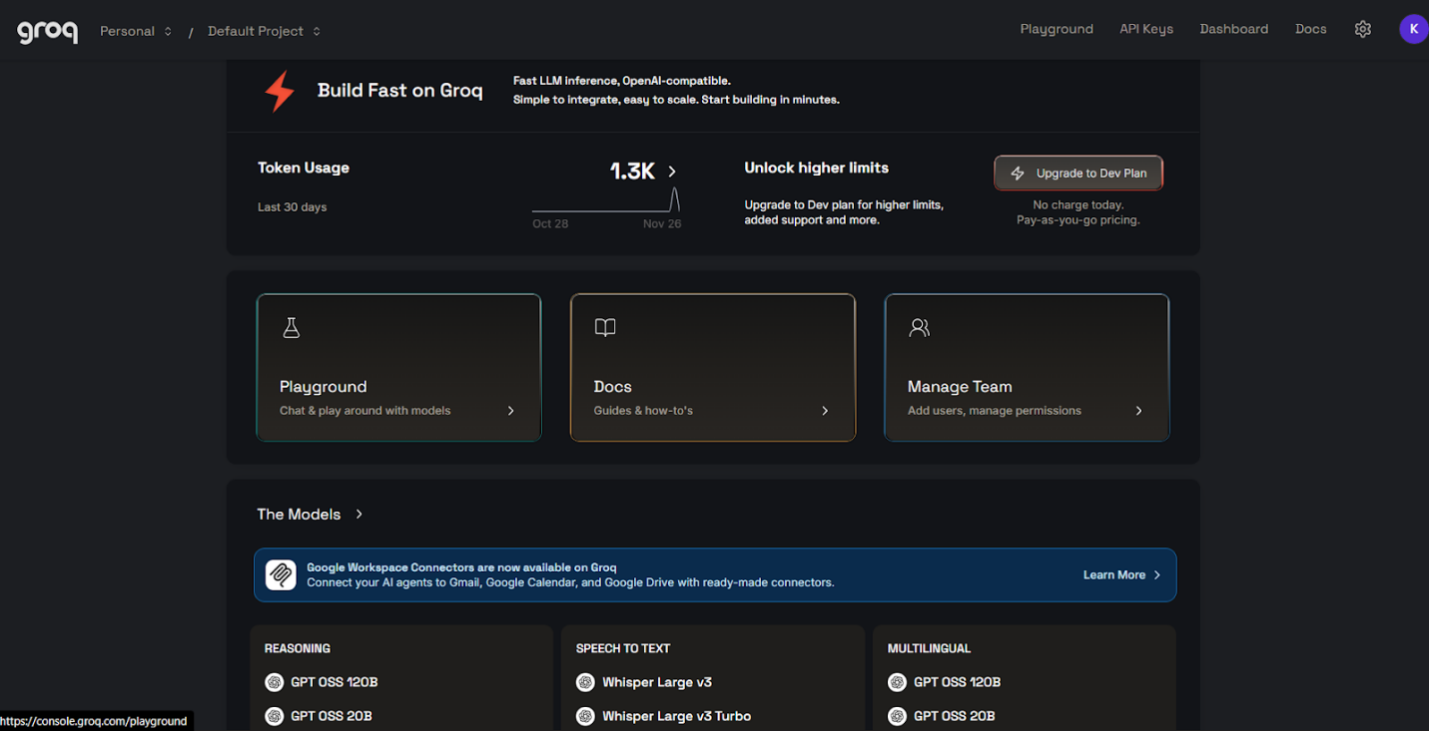
Figure 2: Groq Dashboard
- Validate LLaMA 3.1 inference connectivity.
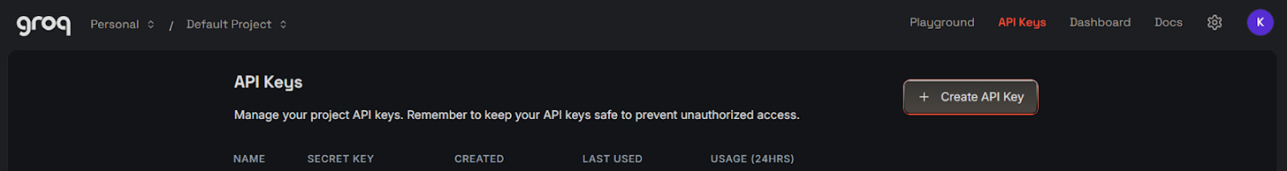
Figure 3: API Key Generator

- Test text generation to ensure stable LLM integration.
• Activity 1.2: Create Python Virtual Environment & Install Dependencies
- Create an isolated environment (e.g. Roadmap/).
- Install required libraries: Streamlit, Groq, Gemini.
- Confirm correct installation and resolve version conflicts.
- Set up project folder structure for images,
MILESTONE 2: User Input & Skill Verification
This milestone focuses on accurately understanding the learner. The system first collects essential user details—including known skills, claimed skill levels, skills they want to learn, and career intentions—through the Streamlit UI. Instead of relying on unreliable self-reported expertise, the system leverages Groq-powered LLMs to generate adaptive MCQs tailored to the user’s claimed skill level.
These MCQs measure practical understanding rather than theoretical familiarity, making the evaluation far more reliable. Once the user answers the questions, the LLM evaluates the correctness of each response and determines whether the user should retain their claimed level or be downgraded.
This ensures that the learning path begins at the correct starting point, preventing scenarios where learners become overwhelmed by advanced material or bored by overly basic content.

Activities:
• Activity 2.1: Implement Input Module for User Profile
- Collect user details: name, known skills, claimed levels, skills to learn, and career goals.
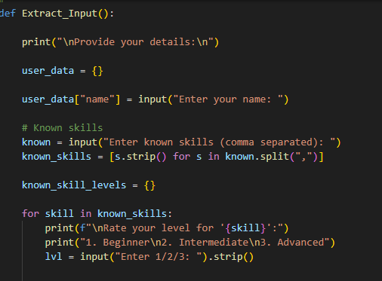
- Standardize inputs into a unified JSON profile.
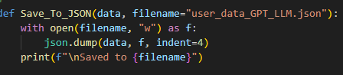
• Activity 2.2: Implement LLM-Based MCQ Generator
- Generate 5 adaptive MCQs for each known skill based on the user’s self-assessed level.
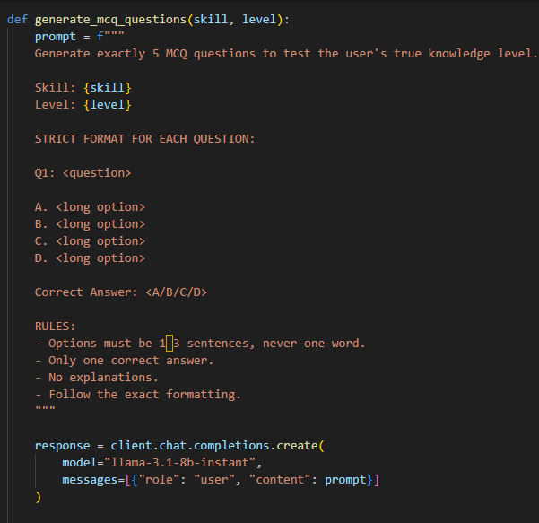
- Structure questions with detailed options and correct-answer keys.
• Activity 2.3: Build Answer Evaluation & Level Verification
- Capture user-selected MCQ answers through Streamlit UI.
- Use Groq LLM to evaluate responses and count correct answers.
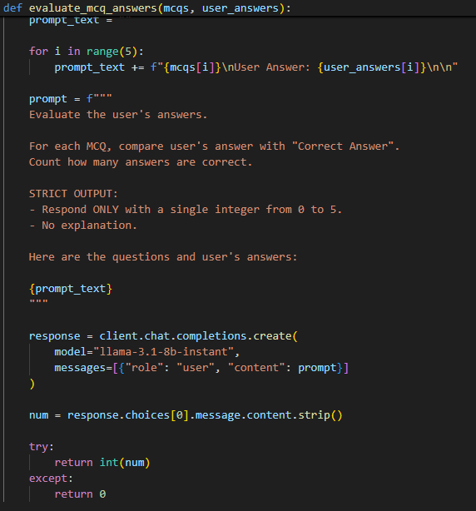
- If the user scores 3 or more, retain their level; otherwise downgrade the level.
MILESTONE 3: Skill Gap Analysis
Once the user’s true skill level is verified, the system shifts to identifying what the learner *must* study next. By comparing the user’s verified skill set to the industry-standard competencies required for their target career path—such as AI Engineer, Data Scientist, or ML Engineer—the Skill Gap Mapping Engine highlights missing concepts, foundational weaknesses, and advanced topics that the user must master.
This analysis becomes the intellectual backbone of the learning plan. The output is transformed into a structured map that includes each needed skill, why it matters, the user’s estimated familiarity, and the urgency or priority of learning it.
By quantifying the gap between the learner’s current state and their desired destination, the system ensures that the final learning path is precise, efficient, and fully aligned with real-world career expectations.

Activities:
• Activity 3.1: Implement Skill Gap Mapping Engine
- Compare verified skills against career-specific requirements.
- Identify missing concepts, weak foundations, and prerequisites.
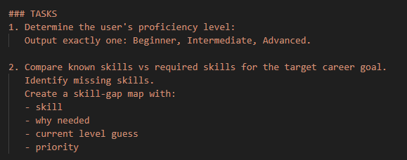
- Generate a structured skill-gap map.

MILESTONE 4: AI-Powered Learning Path Generation
This milestone brings the intelligence of the system to life. The user’s profile, verified skill level, and skill-gap map are converted into a detailed prompt that guides the Groq LLM to generate a highly structured weekly learning roadmap.
The generated plan includes progressively ordered topics, curated resources (YouTube, blogs, courses, documentation), recommended durations, practice tasks, and project suggestions. Each week is designed to build upon the previous one, ensuring learning flow and logical progression.
The system also considers the user’s learning speed and preferred study format, tailoring the amount of weekly content to avoid overload. By the end of this milestone, the learner receives a complete, actionable, and personalized study plan ready to follow.

Activities:
• Activity 4.1: Generate Personalized Weekly Plan
- Convert the user profile + skill gaps into structured prompt data.
- Run Groq LLM to generate a weekly learning roadmap—topics, resources, durations, and tasks.
- Validate plan consistency and feasibility based on learning speed.
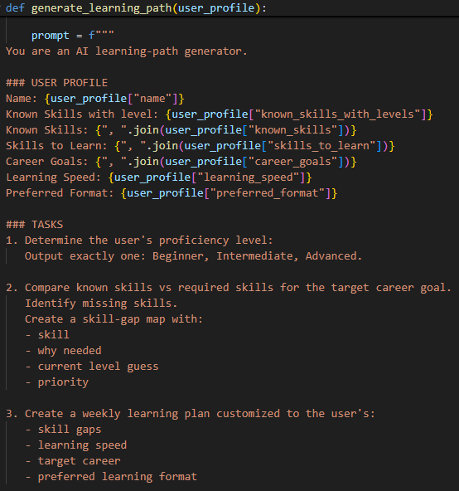

MILESTONE 5: Report Rendering & Optional Visual Roadmap
This milestone transforms raw AI output into polished, human-readable formats. The system compiles all generated insights—required skills, missing skills, gap analysis, and weekly roadmap—into a well-structured instructional report rendered directly in the Streamlit interface.
Learners can download this report as a text file or Word document for offline use, career planning, or academic documentation.
In addition, the project optionally integrates AI image-generation models (such as Gemini or Stability AI) to convert the weekly learning plan into a visual roadmap infographic. This visualization is ideal for presentations, portfolios, or motivation tracking. By the end of this milestone, the system provides both textual and graphical clarity of the entire learning journey.

Activities:
• Activity 5.1: Generate Human-Readable Learning Report
- Convert LLM output into a structured instructional report.
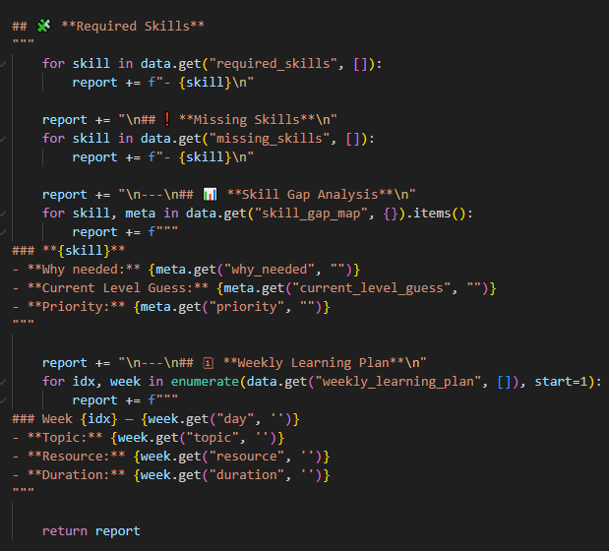
- Display required skills, missing skills, skill-gap analysis, and weekly plans.
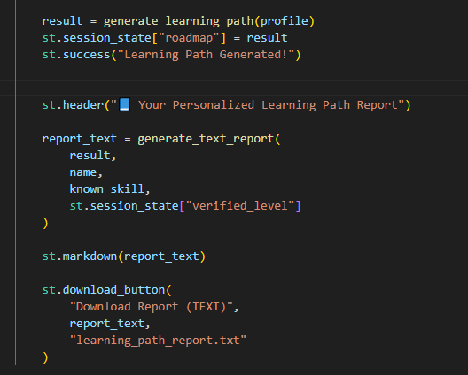
- Enable download as text or DOCX.
• Activity 5.2: (Optional) Generate Visual Roadmap Image
- Use Gemini, Stability AI, or similar models to create a visual learning timeline.
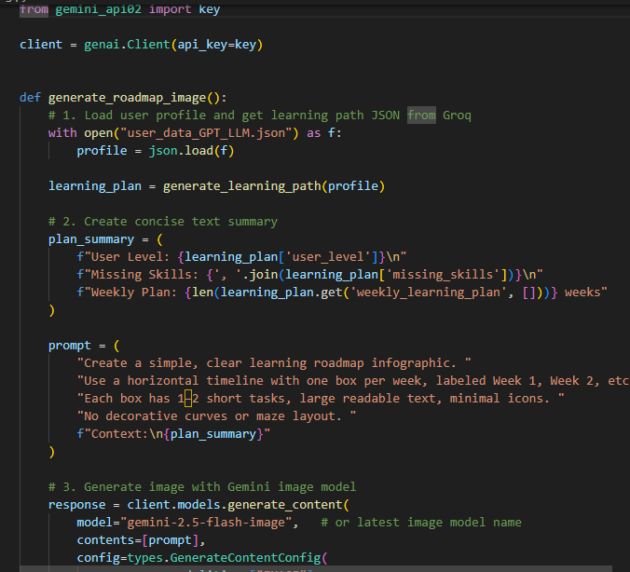
- Save the infographic for documentation or presentations.
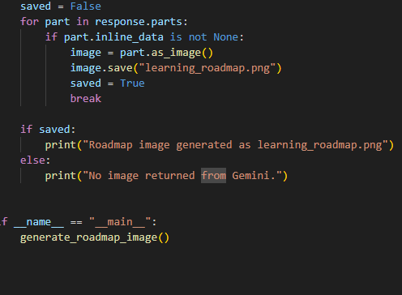

MILESTONE 5: Report Rendering & Optional Visual Roadmap
The final milestone ensures the platform is stable, efficient, and user-friendly. UI navigation is tested from start to finish—Input → MCQ → Verification → Learning Path → Report—to guarantee a smooth user experience.
LLM responses are evaluated for consistency, MCQ scoring is validated, and learning-path logic is refined to reduce redundancy and improve accuracy. The Streamlit interface is optimized for responsiveness, caching is adjusted for performance, and API calls are streamlined to prevent latency.
Once all components perform reliably, the system is prepared for deployment on local servers, cloud platforms, or internal organizational environments.

Activities:
• Activity 6.1: System Testing & Optimization
- Test UI navigation flow (Home → Input → Output).
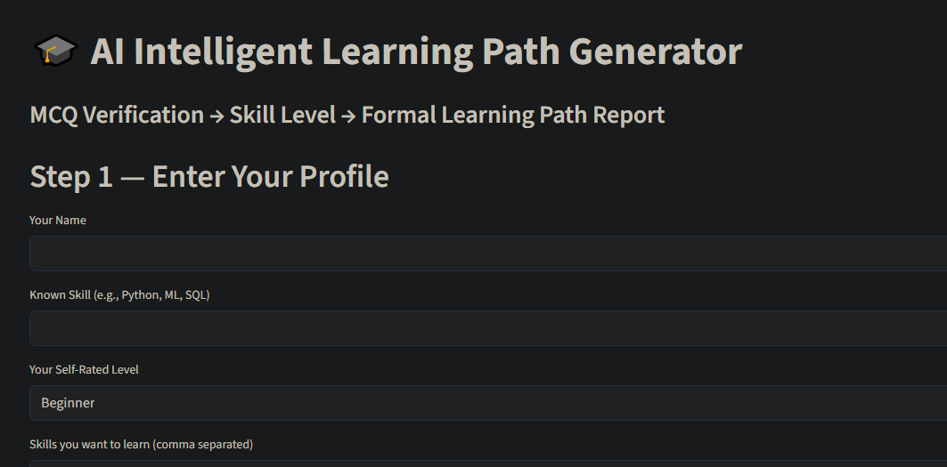
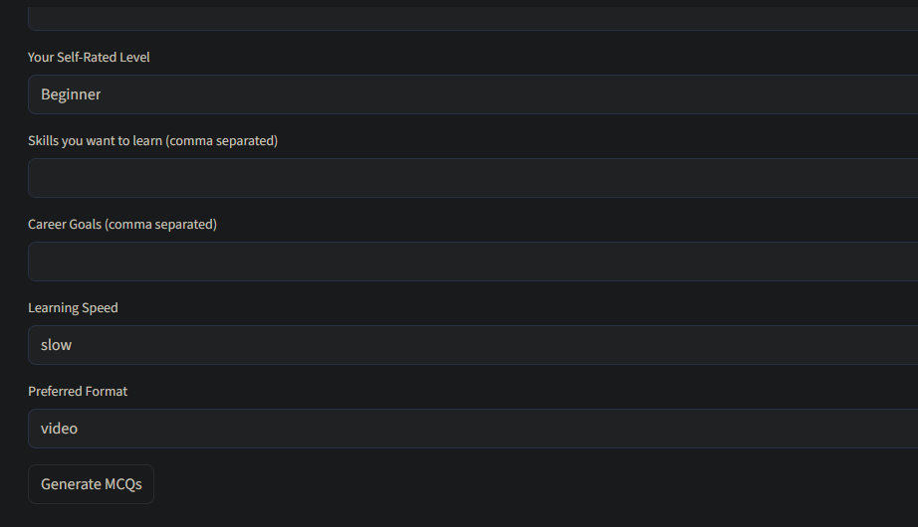
- Validate MCQ accuracy, LLM responses, and learning-path alignment.
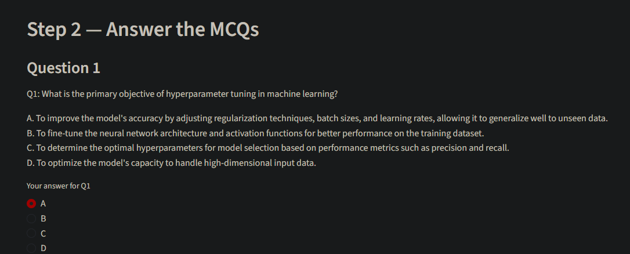
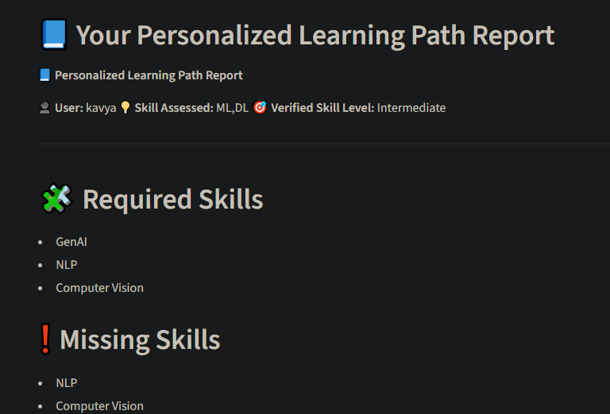
- Optimize caching, API calls, and user interaction flow.
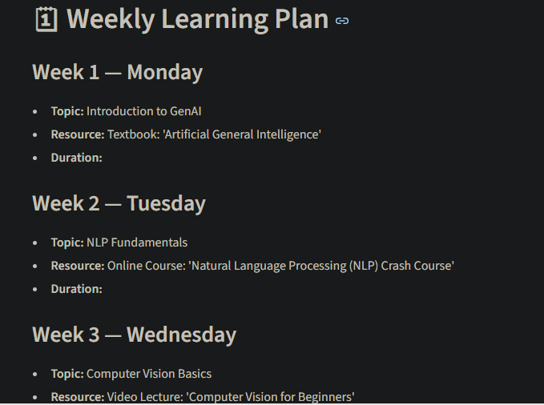
Conclusion
The AI Learning Path Generator successfully combines LLM intelligence, structured skill verification, and personalized curriculum design into one unified platform. By evaluating users through adaptive MCQs, identifying precise knowledge gaps, and generating optimized weekly learning plans, the system delivers a highly tailored and efficient path toward skill mastery.
Its modular backend, interactive Streamlit frontend, and Groq-powered reasoning capabilities ensure transparency, reliability, and scalability. Whether for students, working professionals, or academic institutions, the system empowers learners to navigate rapidly evolving AI domains with clarity and confidence.
This project demonstrates how modern AI can transform personalized learning, offering guidance that is both intelligent and adaptive—bringing expert mentorship within reach of every learner.

